CREATE POS SALES ORDER WITH DEPOSIT INTO SALES
On Home Page go to Point of Sale
Select New Sales Order
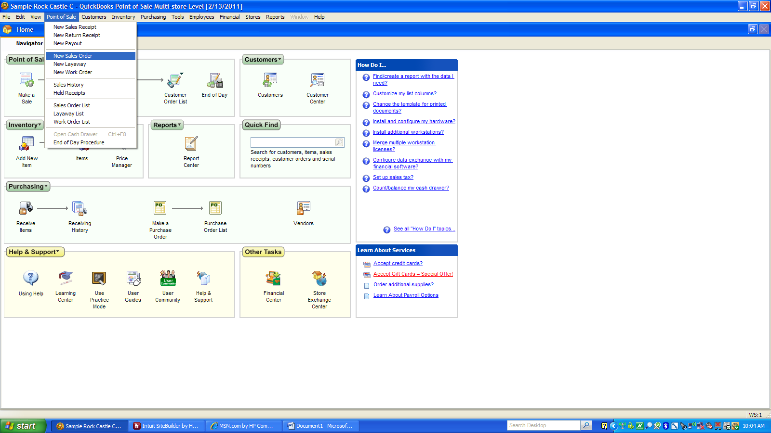

Create your sales order
To record deposit select “I Want To”
Select Take Payment/Deposit
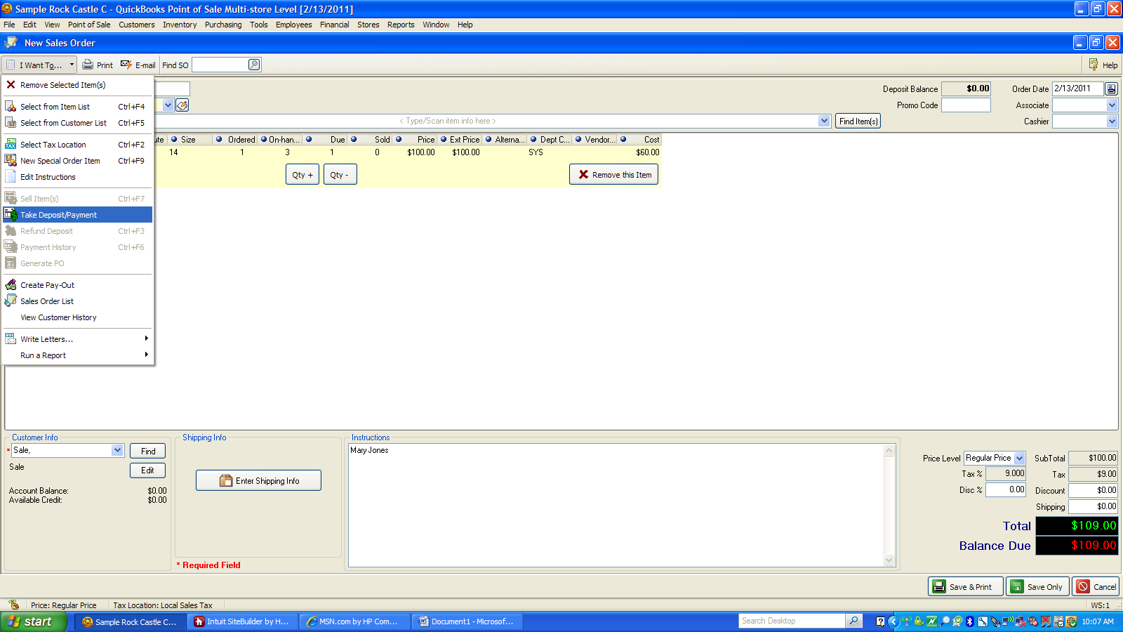

Enter Deposit Amount
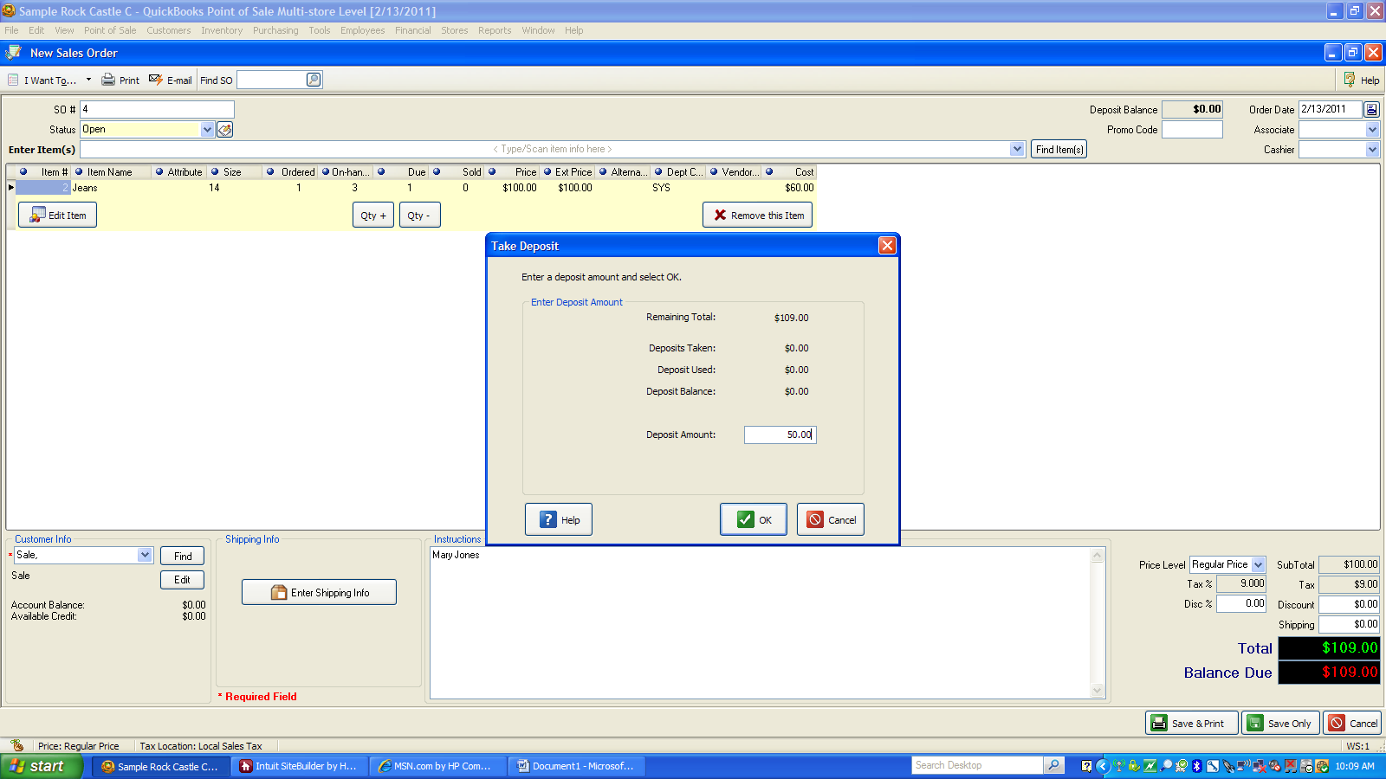

Select type of payment
Select Accept Payment
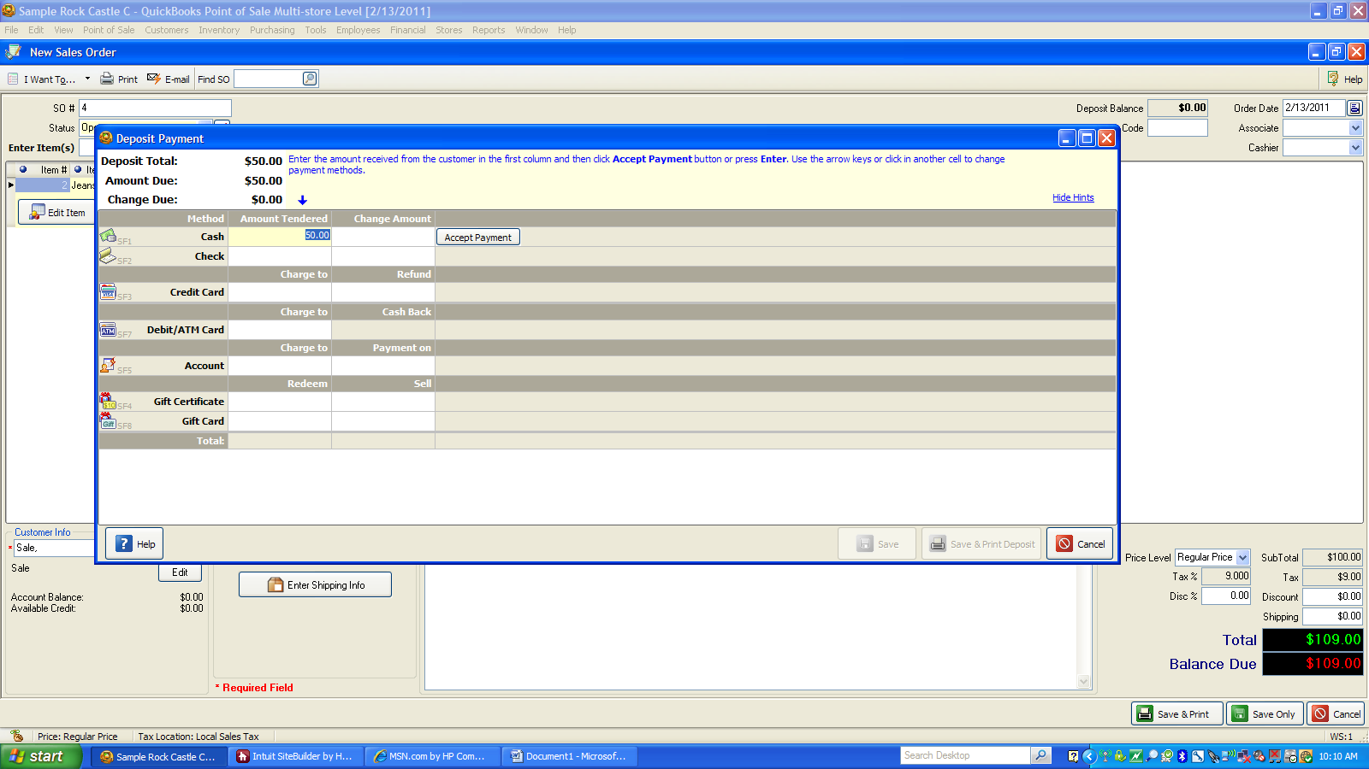

Select Save & Print
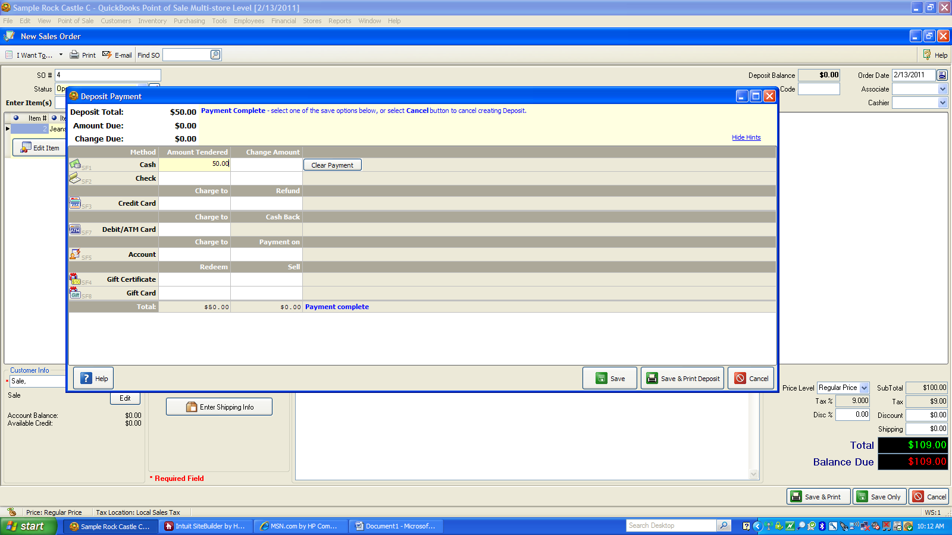

Select Close Screen
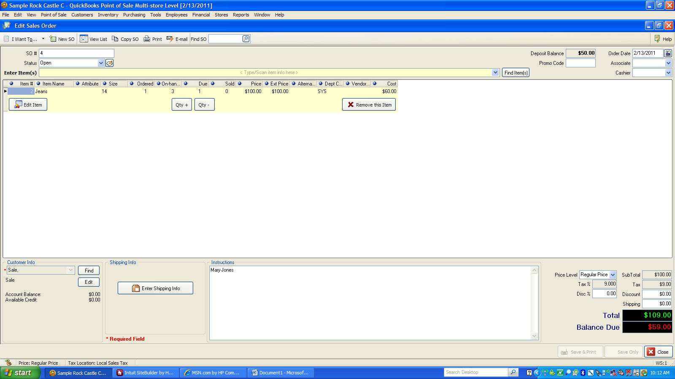

This will post $50.00 to Customer Deposits and cash to be deposited in QuickBooks and will not record any sales at this point.

To complete sale with the final payment
Go to Point of Sale
Select Sales Order List
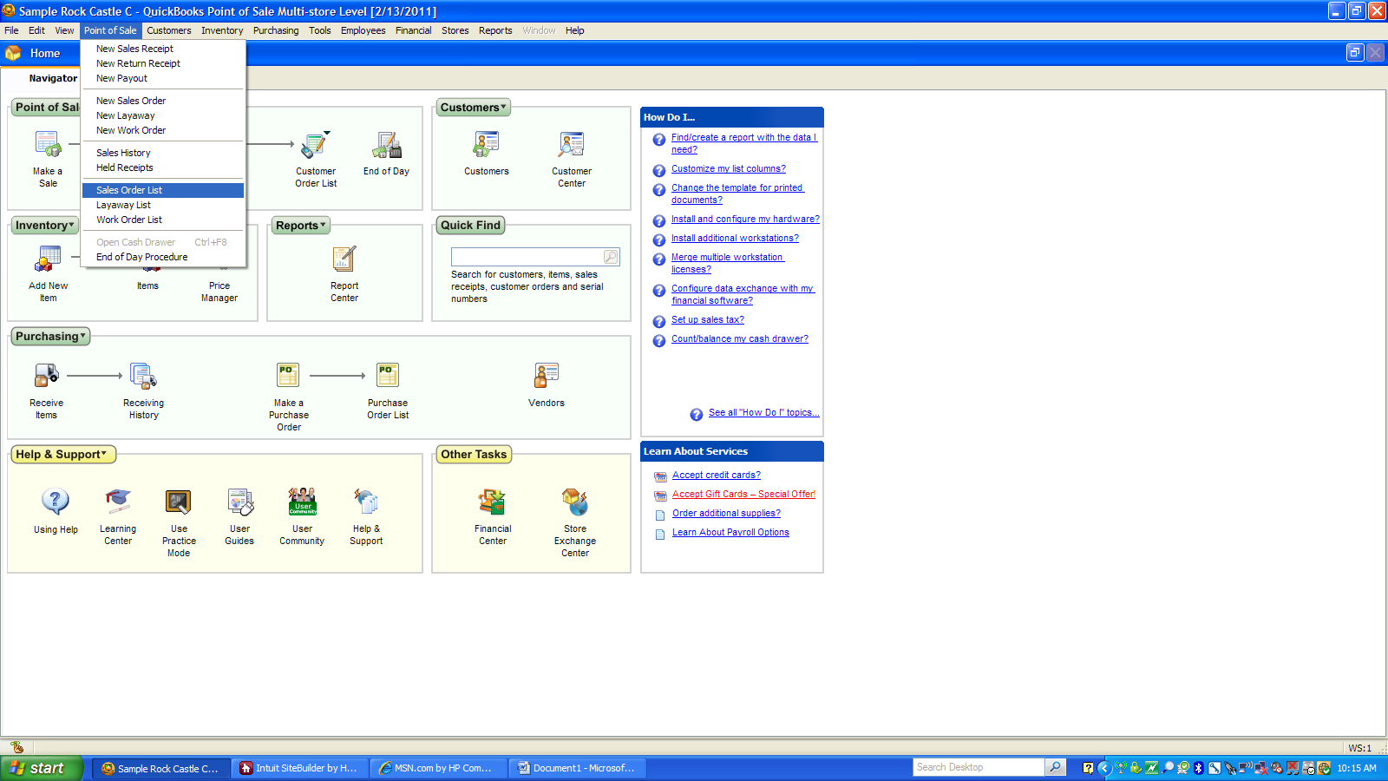

Select the sales order you want to complete
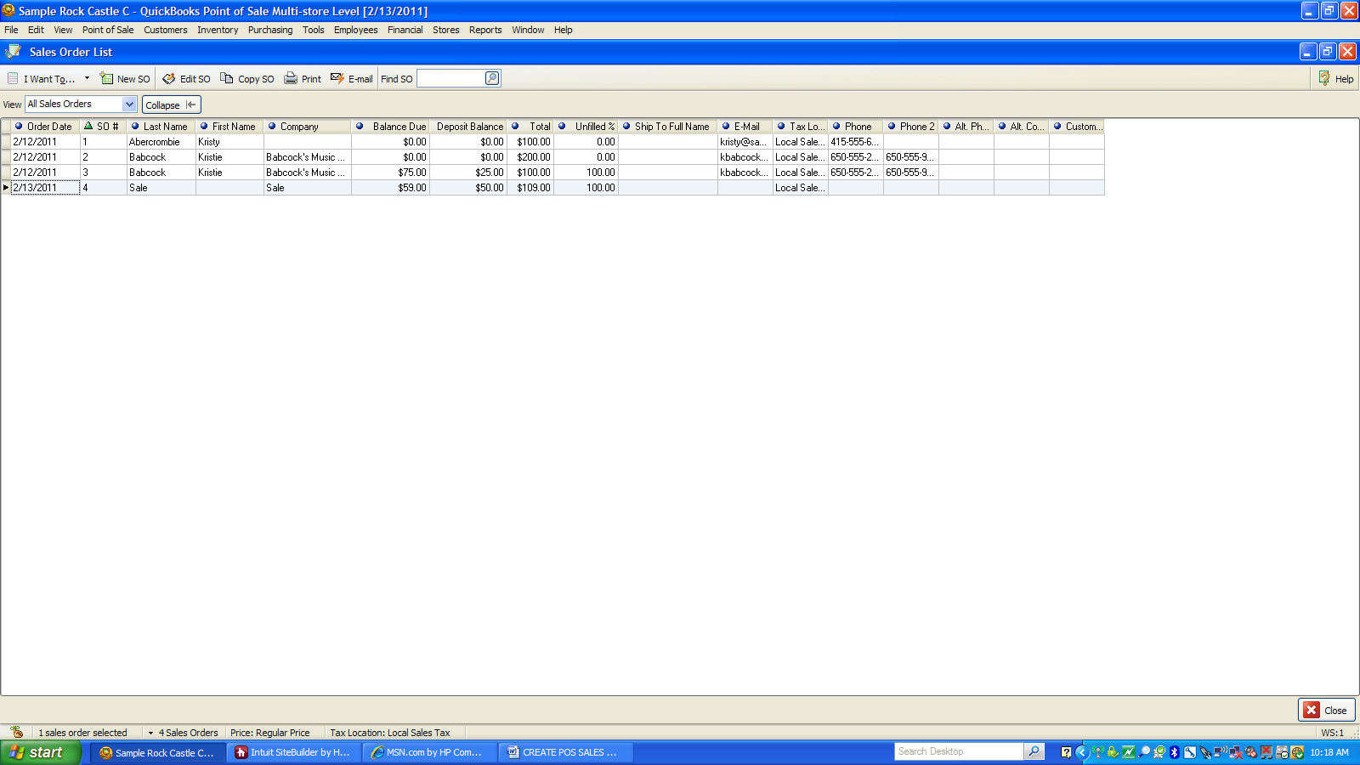

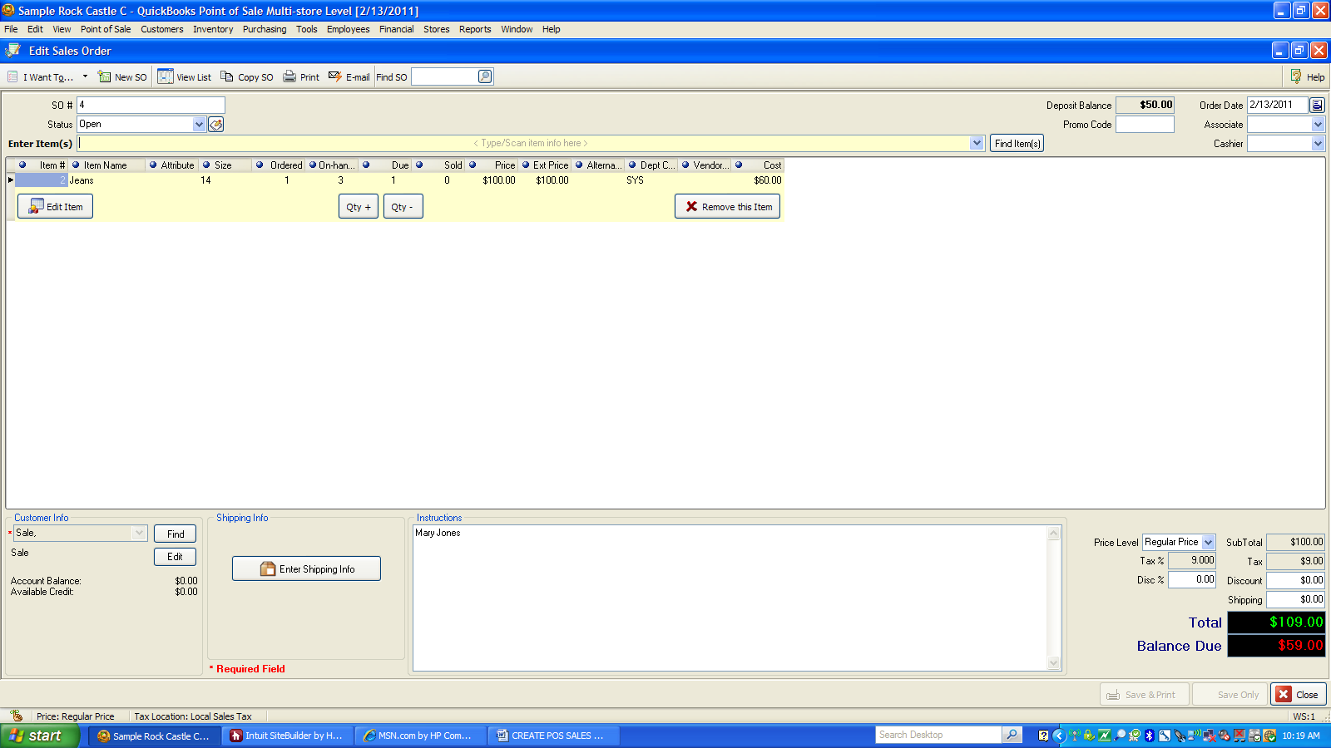

Select “I Want To”
Select Sell Items
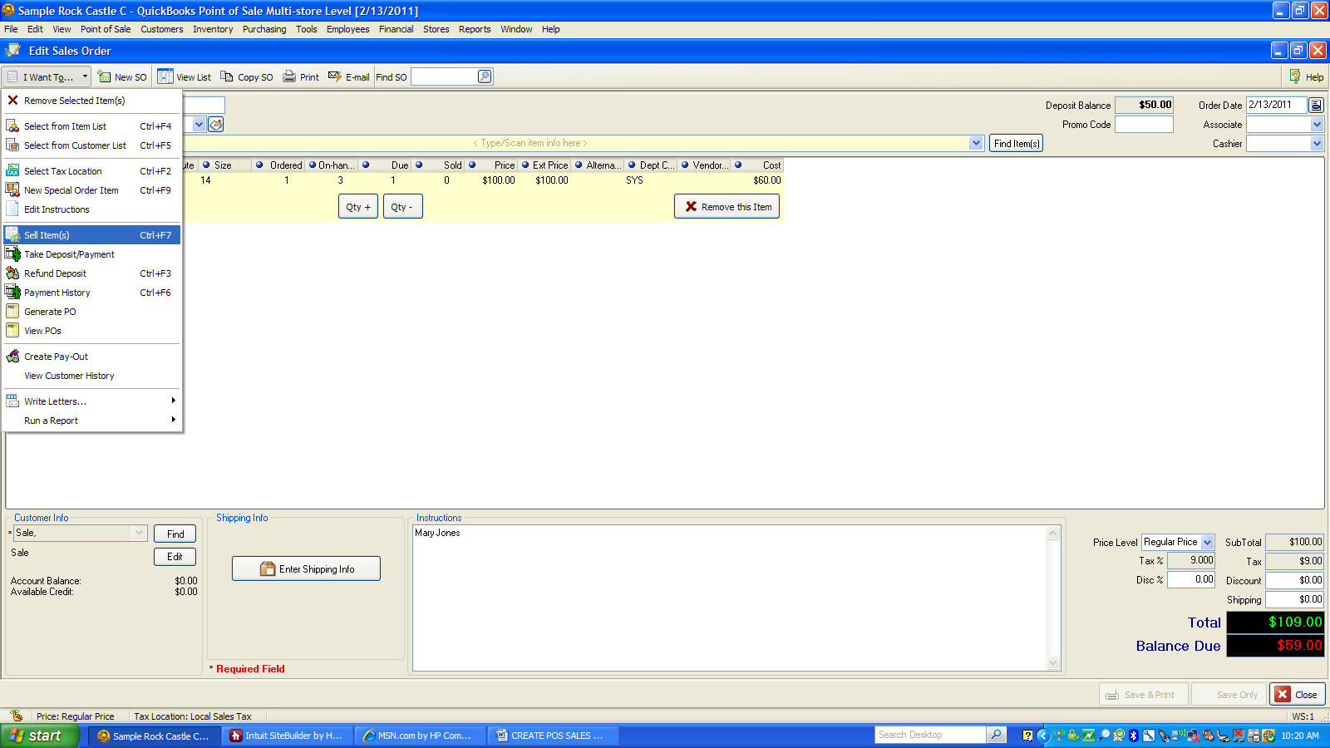

Select All
Select Continue

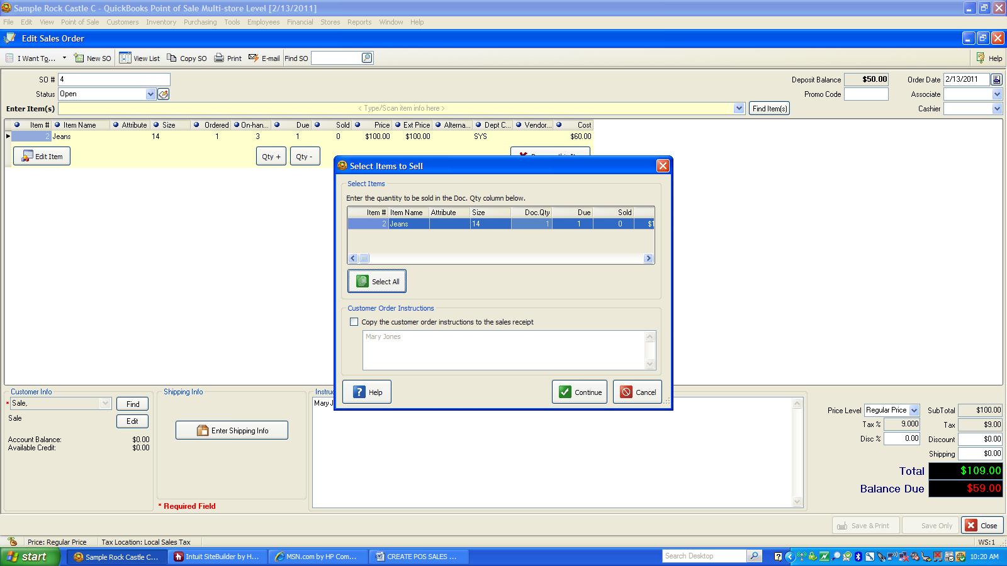

Select Take Payment
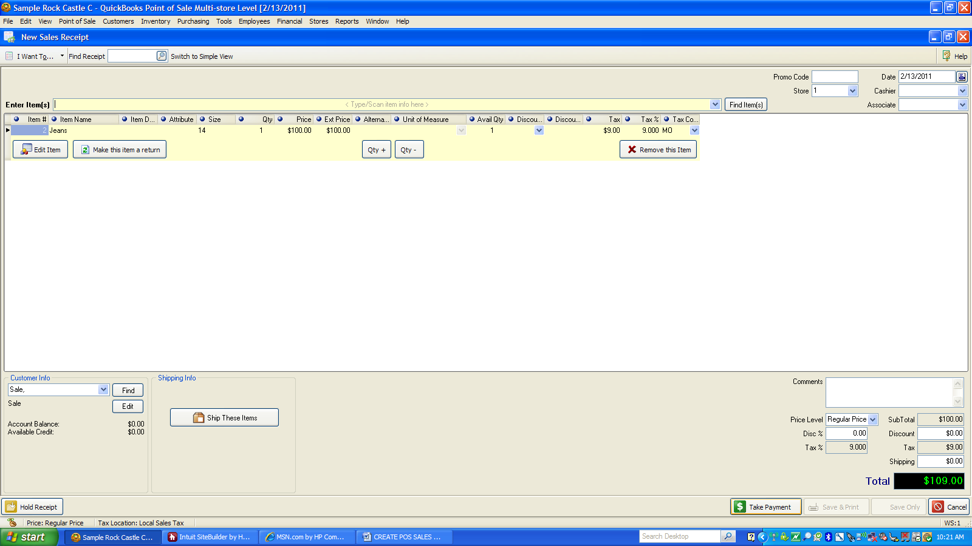

The remaining amount and deposit will fill in. You will need to select the type of payment and accept payment.
You again will need to select Save and Print
This will take you back to your sales order list and you will see that the total on balance due to -0-. When this posts to QuickBooks it will record this as a sale and reduce your customer deposits and record the cash that was received from the final transaction ($59.00 in this transaction) to be deposited.

