Five Steps to Implement QuickBooks for Nonprofits

Step 1: QuickBooks Lists
Your clients will appreciate your expertise in making sure they properly set up the QuickBooks lists to manage the financial recording needs of the NPO.

Chart of Accounts
Having a comprehensive chart of accounts will help your client correctly report revenue and expenses during the year on IRS Form 990. When creating or editing a chart of accounts, you have these options:
Unified Chart of Accounts. This is provided by the National Center for Charitable Statistics (NCCS) and available for download as a ready-made QuickBooks backup file or as an importable iif format file. The unified chart of accounts is already created; all you have to do is remove the “x” in front of the account(s) you will be using, with the remaining accounts left as inactive so they will not be displayed when recording transactions.
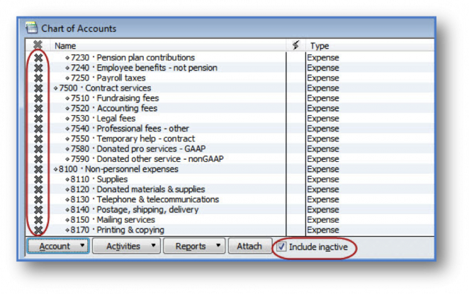
- QuickBooks Easy Step Interview. From an open QuickBooks file, select File, New Company and then choose the Start Interview option. You will be able to select from a list of industries that include a ready-made chart of accounts for nonprofits.
- Create Your Own Chart of Accounts or Import From Excel. From an open QuickBooks file, select QuickBooks, Lists, Chart of Accounts. The QuickBooks Chart of Accounts varies slightly from the UCOA used by the NCCS site. Manage the list here by adding accounts or editing existing accounts. You can also import a list from Excel. For accounting professionals, importing from Excel can be a simple way to make sure your client uses the proper accounts.

Service Items List
QuickBooks Items are necessary when using sales forms with donors. At a minimum, you will need to create a service item for each revenue general ledger account. To create an item, select Items List from the Lists menu. Use the Service Type item and name it the same as your revenue account(s). You will then assign the individual revenue account to the item.
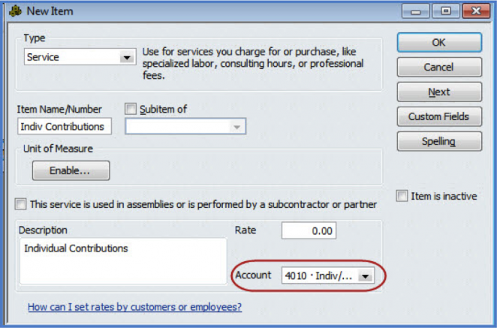
Another useful purpose for the items list is creating an item for each “expense” the organization will have. While this is not required, it helps ensure that transactions are coded to the proper account.

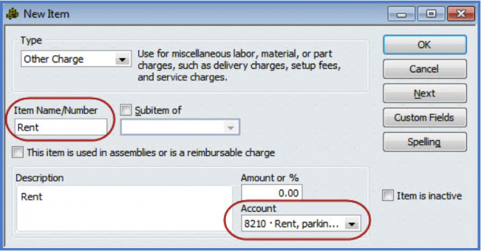

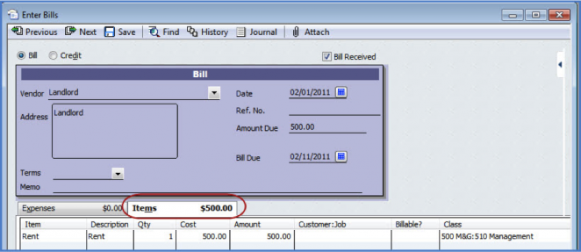

Class List
Using the class list for programs and activities will enable your client to print revenue and expense reports for a specific activity. This also allows the QuickBooks user to have simple, streamlined income and expense categories.
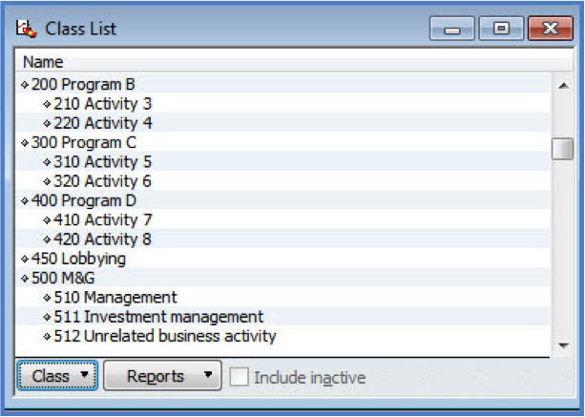
When an activity is completed, the class can be made innactive so that it does not appear in a drop-down menu for new transactions.

Step 2: Create Grant Estimates
Use the Estimate form to prepare and track proposals that are awaiting approval. This form does not report revenue until you create an invoice, making it the perfect form for tracking and submitting proposals.
The key to proper grant reporting is to use the Customer:Job field for each individual grant. This process will also provide reporting on income and expense for the Customer and for the specific Job.

Step 3: Track Costs of Programs and Grants
When a grant is approved, properly recording costs to the individual program or grant is important for maintaining the organization’s NPO status with the government.
Each line of the expense transaction should have a program or activity assigned (class). You can set a preference in Edit, Preferences, Accounting, Company Preference to be reminded if your client is recording a transaction without a class assigned. Assigning the unique program or grant is important for reporting on actual vs. budget or resulting income less expenses specific for that fundraising activity.
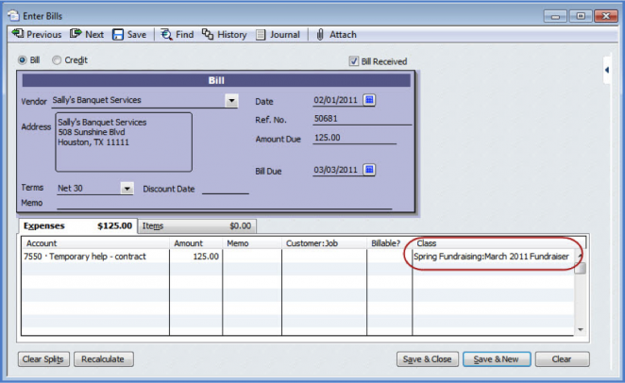
If you are recording a cost for a grant expense, be sure to also assign the Customer or Customer:Job field to the expense for proper reporting on income and expense by grant.

Step 4: Recording Money Received
QuickBooks has a variety of forms that can be used to track the receipt of money by the nonprofit organization.

Sales Receipts
If the organization receives payment immediately at an activity, sales receipts can be used to record the money received (using the items created earlier) as well as the method of payment. If end-of-year statements are needed for the individual donors, then you would also need to create a donor (customer) record to record the sales receipt.
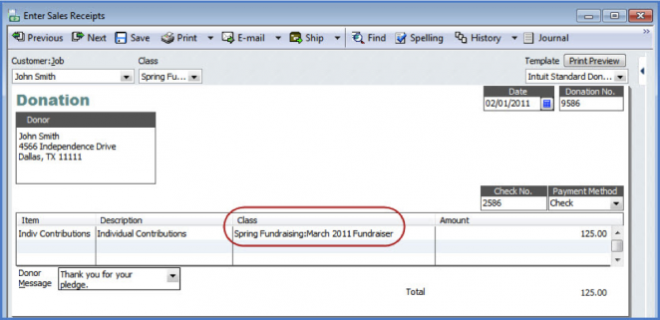

Invoices
If the organization accepts pledges for donations, and the money will be received later, using the QuickBooks invoice form will easily track this detail. In addition, QuickBooks has a variety of reports that provide details of who owes the money, and for what activity the pledge was made.
If the nonprofit created an estimate (proposal) for the grant, the invoice details can be automatically added to the invoice form, avoiding duplicate effort. Simply open the Estimate and select Create Invoice.
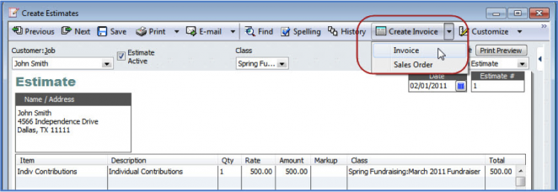
New for QuickBooks Premier 2011 and QuickBooks Enterprise Solutions 11.0 is a Balance Sheet by Class Report. This report will enable a nonprofit to report on open pledges or grants (accounts receivable) by Class. For this report to work correctly, your client must use either Sales Receipts or Invoices to record the receipt of money.

Make Deposits
The Make Deposits form has been a common tool for recording money received by nonprofits without creating a sales receipt or invoice form. This method properly records the money received in the bank account register and provides details when preparing a Profit & Loss by Class report. However, using the Make Deposits form will not provide the needed information for the Balance Sheet by Class report.

Step 5: Budgeting and Reporting
The effort spent properly setting up QuickBooks will ensure that your client’s internal reporting needs and compliance with NPO standards will be met.
Help your clients set up a program budget in QuickBooks and they will see how simple it is to create a budget for future fundraising activities. From the menu bar, select Company, Planning & Budgeting, Set Up Budgets. Clients can set up a budget for Profit & Loss or Balance Sheet, and then select the Class criteria when creating a budget for a specific fundraising activity.
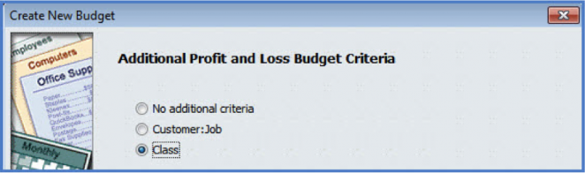
The budget can be created from scratch, or if creating a budget for the organization as a whole, a budget can also be created starting with the prior year’s actual data. Using a grid like entry form, enter the budget details.
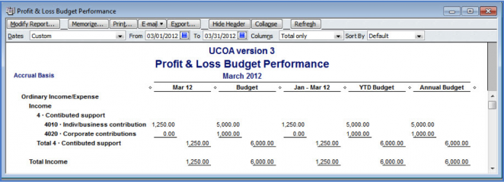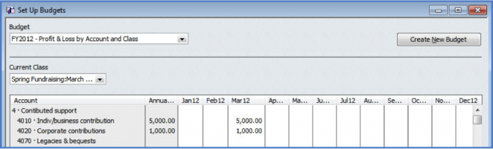
Then, from the Reports menu, select Budgets & Forecasts and select Profit & Loss Budget Performance (or any of the other provided Budget reports).

Also look in the Reports, Company & Financial section for Profit & Loss by Class reports. Or, the Profit & Loss Unclassified report will help locate any transactions that were not recorded to a fundraising activity.

