Procedure for End of Day
- Go to Point of Sale Home Page
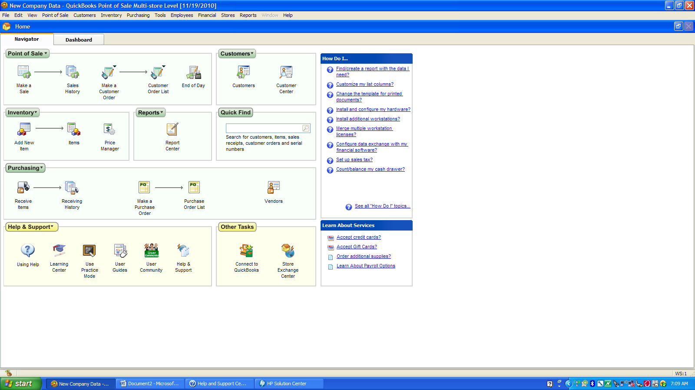
- Select “End of Day”
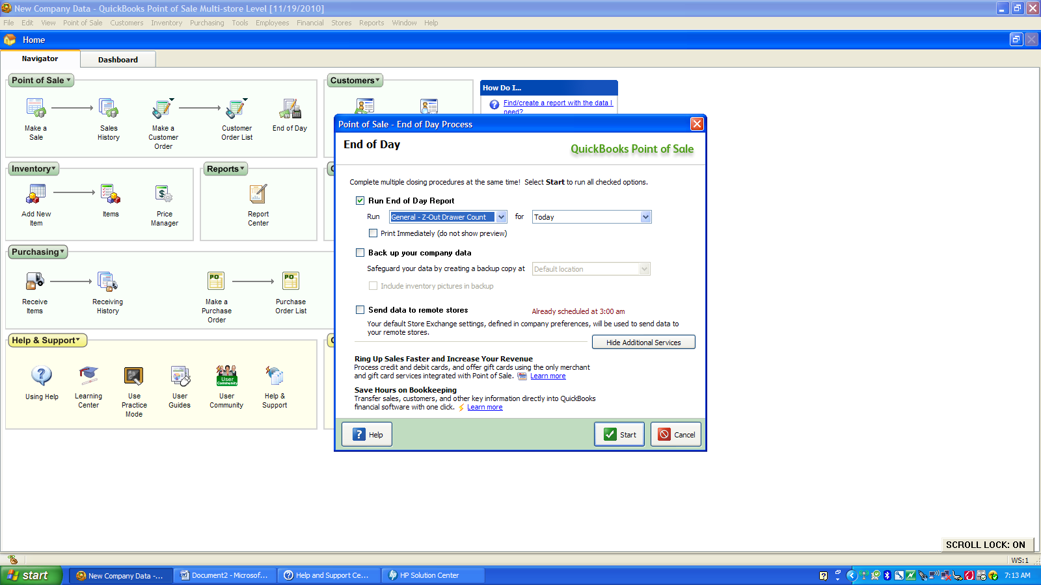
- Everything should be unchecked except “Run End of Day Report”
- Select in the boxes under “Run End of Day Report” “General-Z Out Drawer Count” “Today”
- Select Start
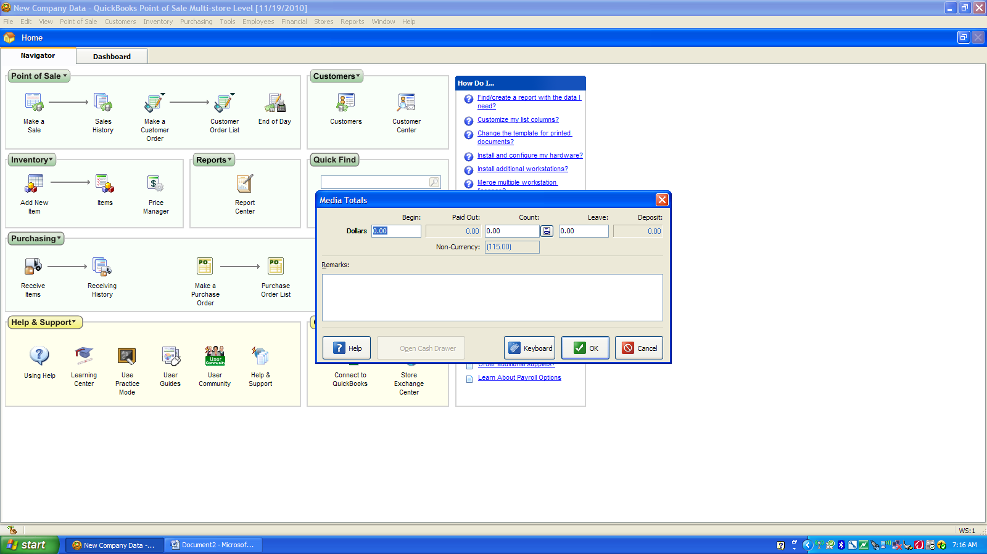
- “Media Totals” box should pop up
- Enter the amount that was in the drawer at the beginning of the day
- Select the button by the “Count” box
- A “Media Count” box should pop up 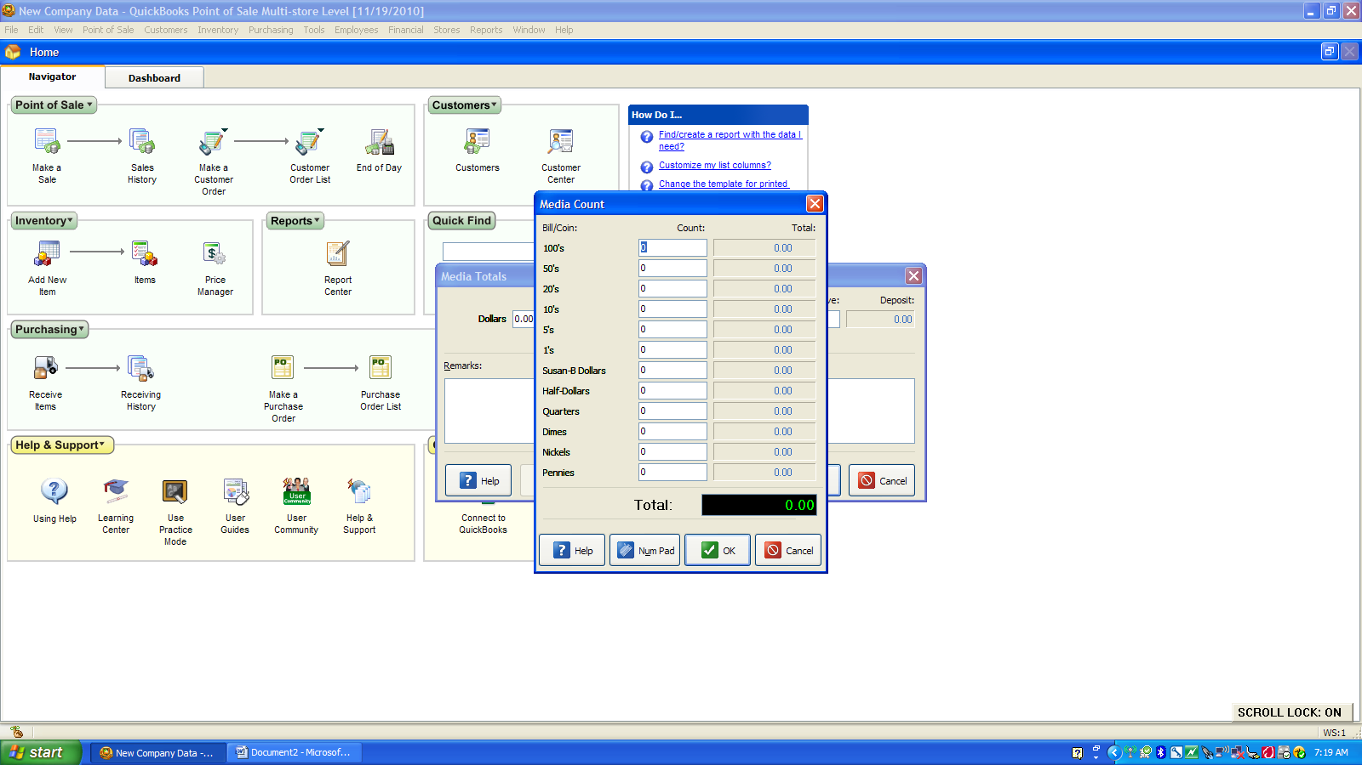
- Enter the NUMBER of each of the denominations of currency in the box. It will calculate the total dollars to the right.
- When completed select “Ok”. It will take you back to the previous screen
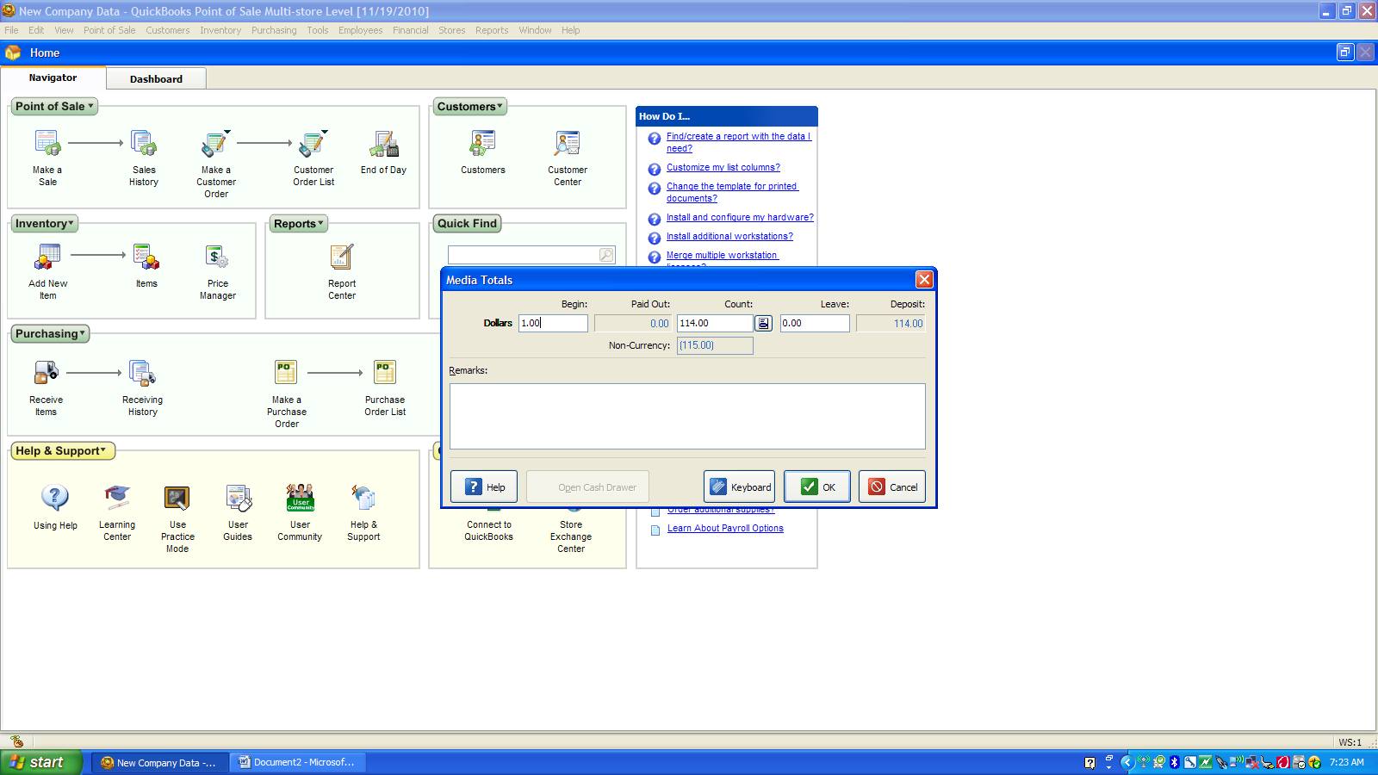
- Select “Ok”
- The next screen will tell you if you are over/short or in balance
- It will be your decision to recount the money if you are over or under
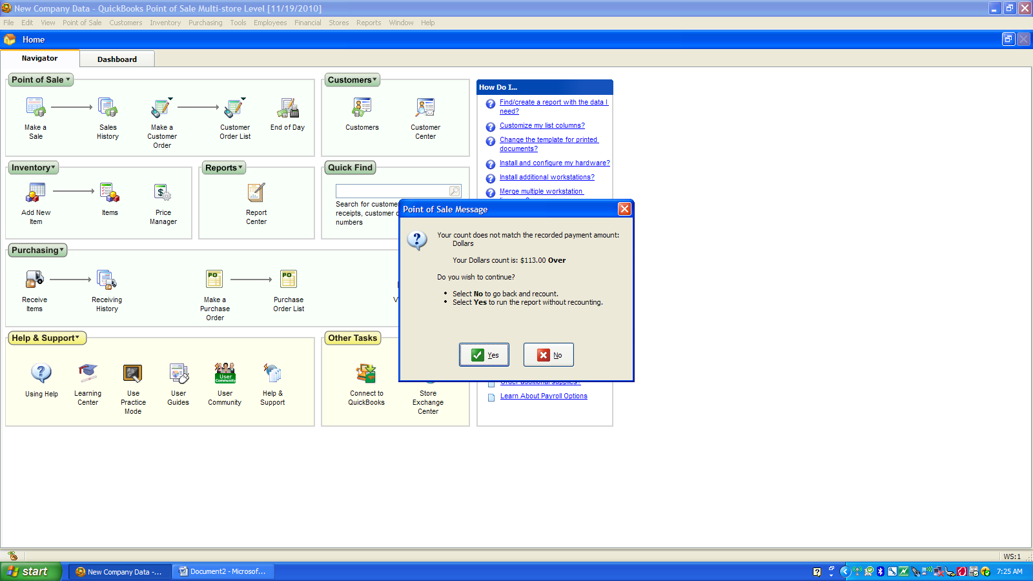
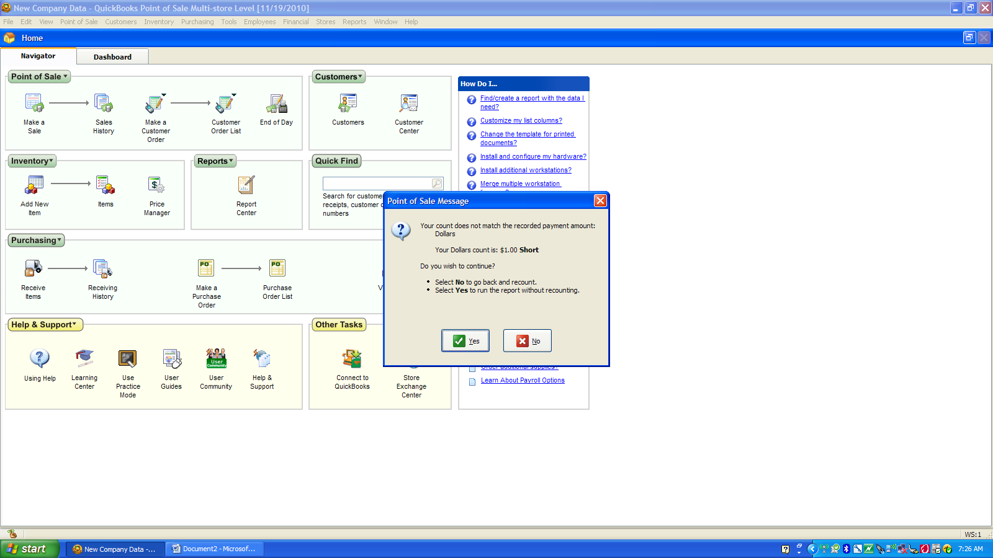
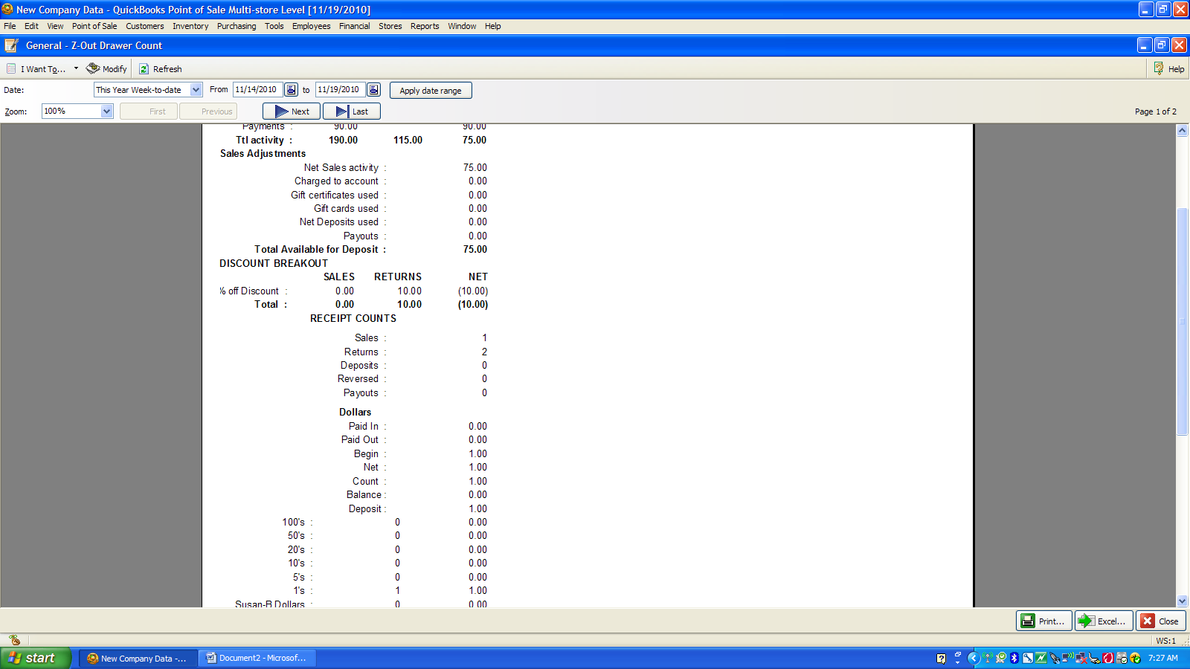
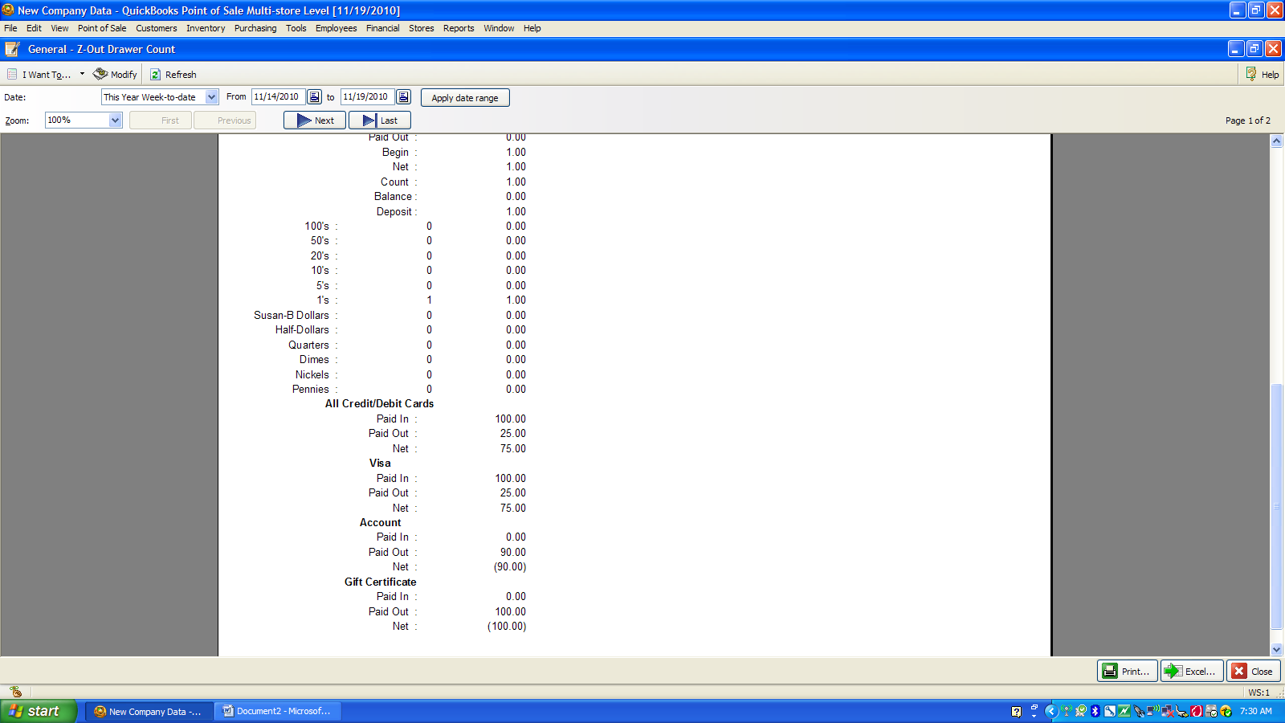
- This page will tell you how much you have to deposit and where the deposit is coming from like the type of charge card etc.

