Paying Sales Tax
DO NOT PAY SALES TAX THROUGH YOUR ACCOUNTS PAYABLE. YOUR GENERAL LEDGER WILL NOT BE CORRECT IF YOU DO.
Run a Profit and Loss for this fiscal year as of the end of the period you are paying sales tax

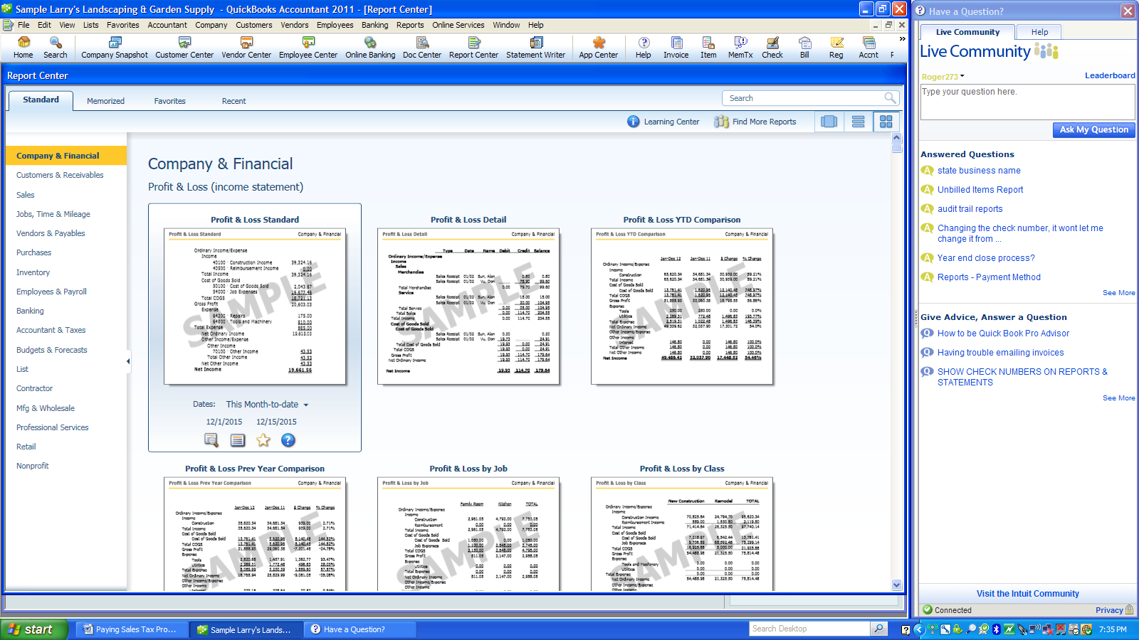
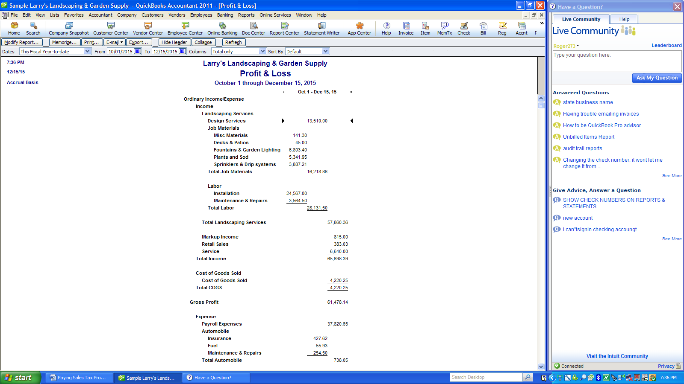

Fill in Excel spreadsheet
This tells you the amount of sales you should record
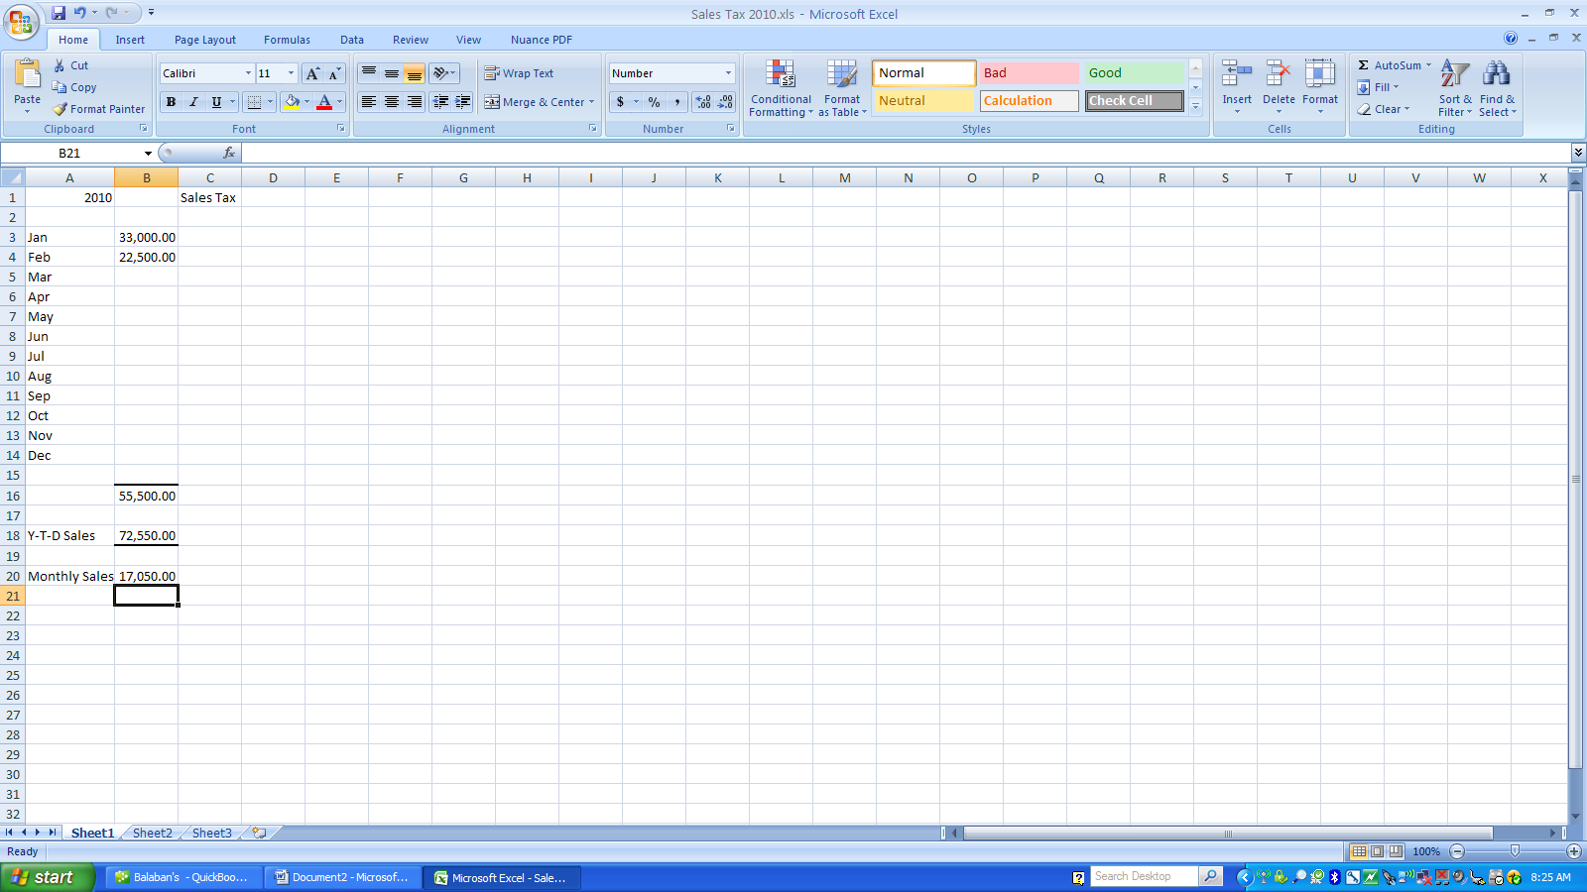

Run a Balance Sheet as of the end of the period you are reporting
This should give you the amount of sales tax that you we
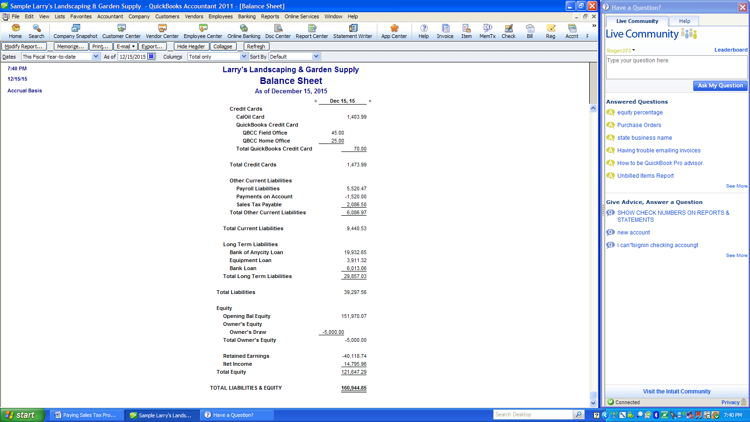
Select Manage Sales Tax
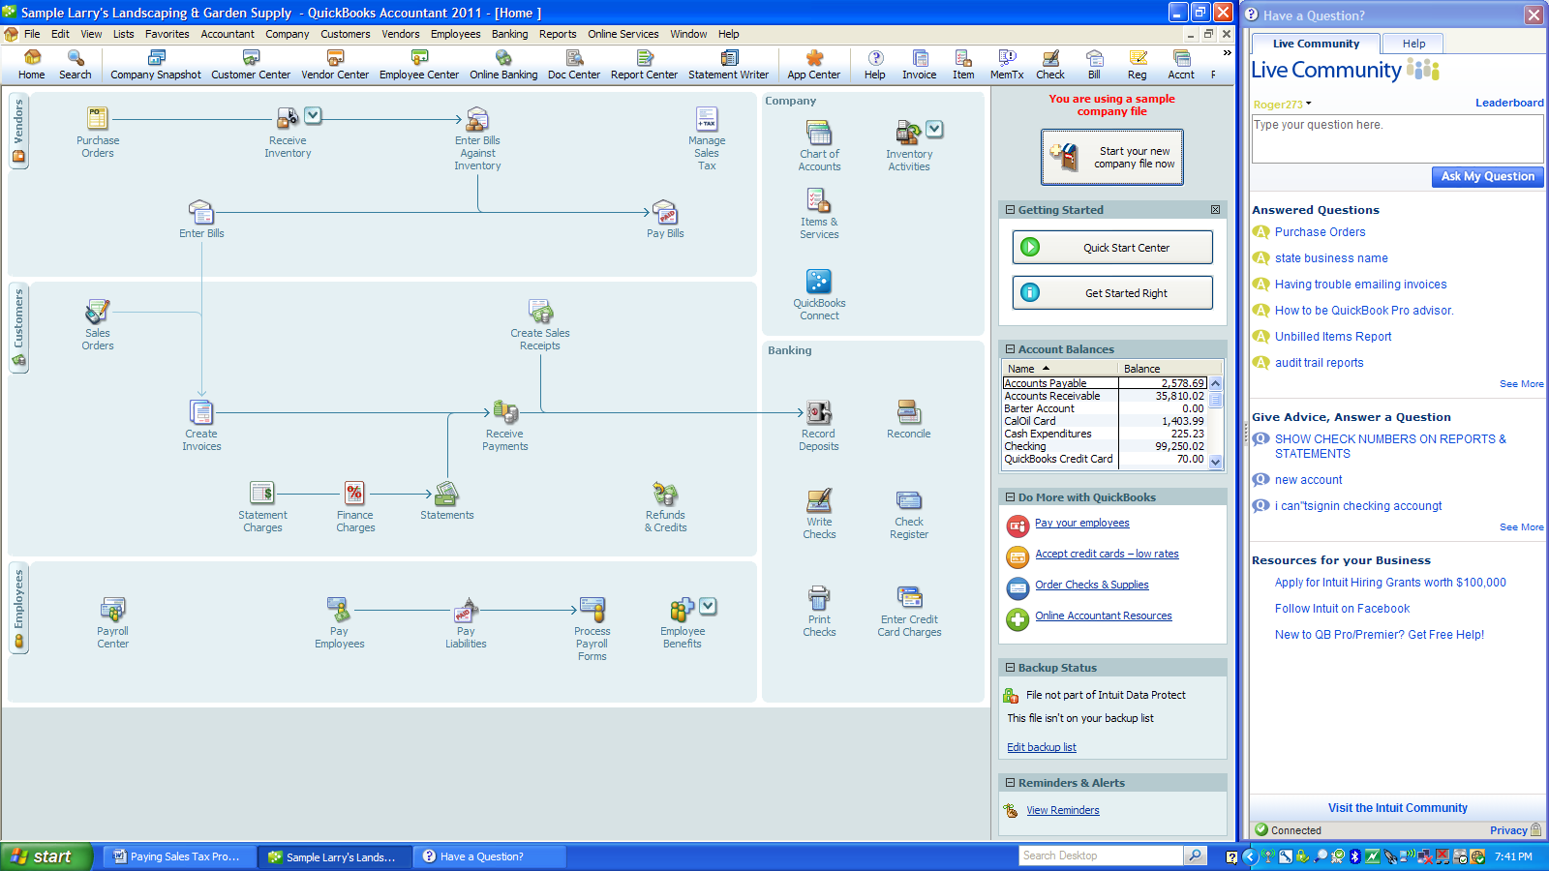
Select Sales Tax Liability
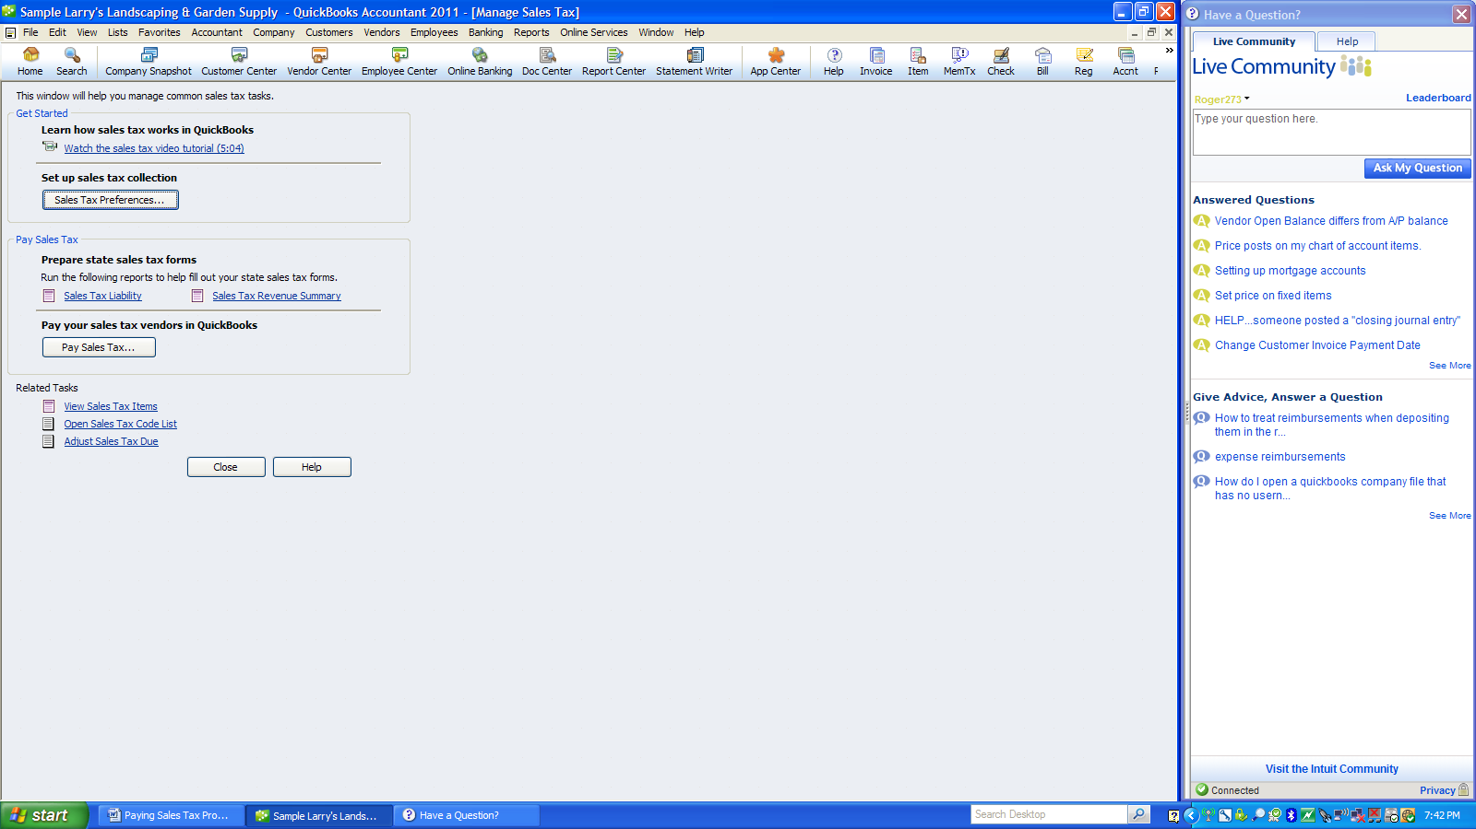
This will give you a report of what is to pay without any adjustments
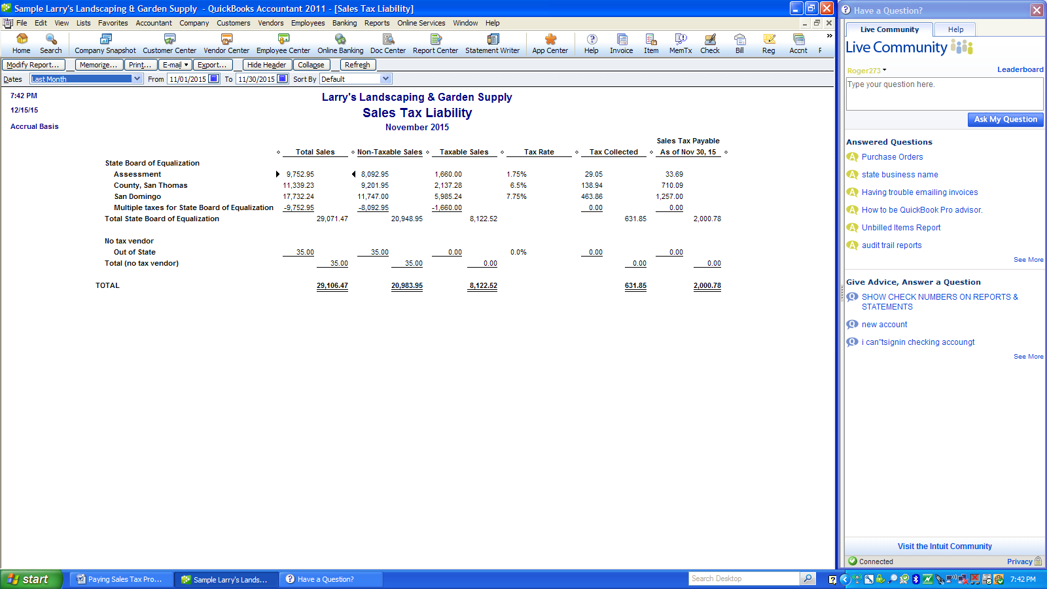

Select Pay Sales Tax

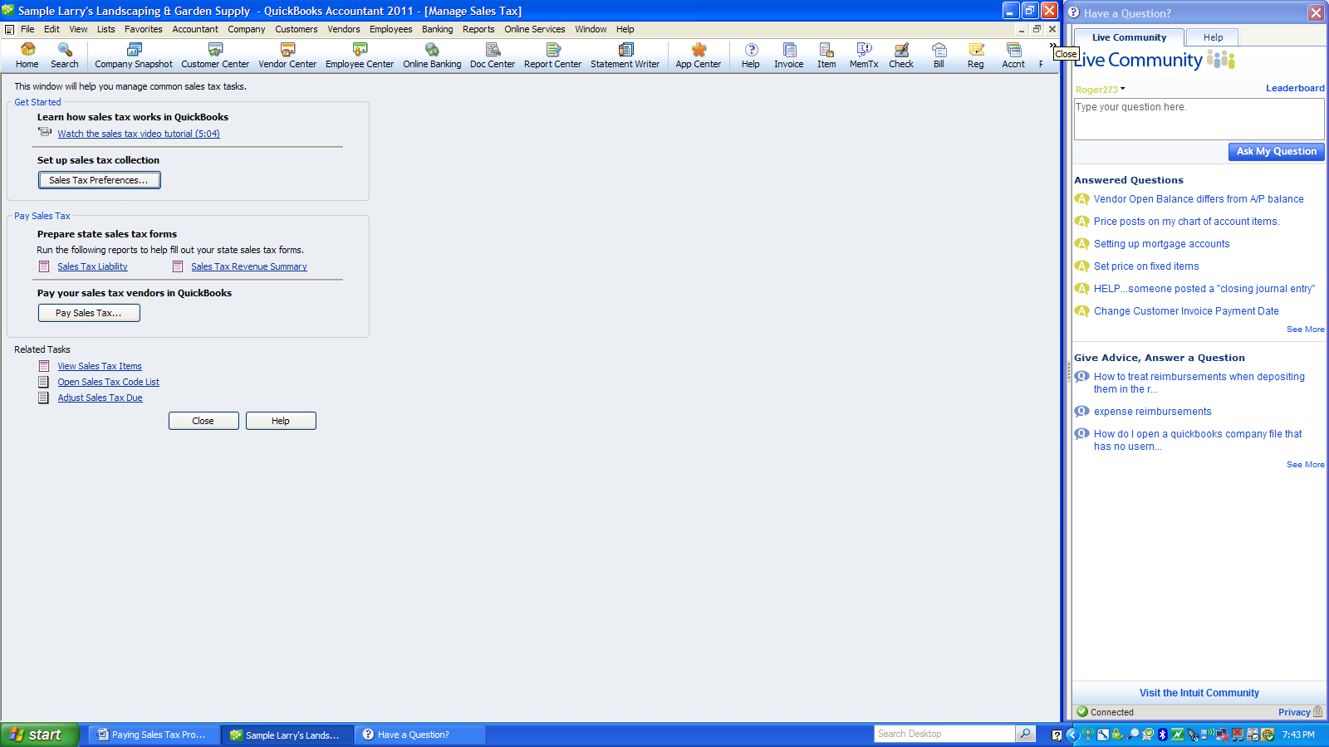
This will give you a screen to adjust your sales tax to what you owe
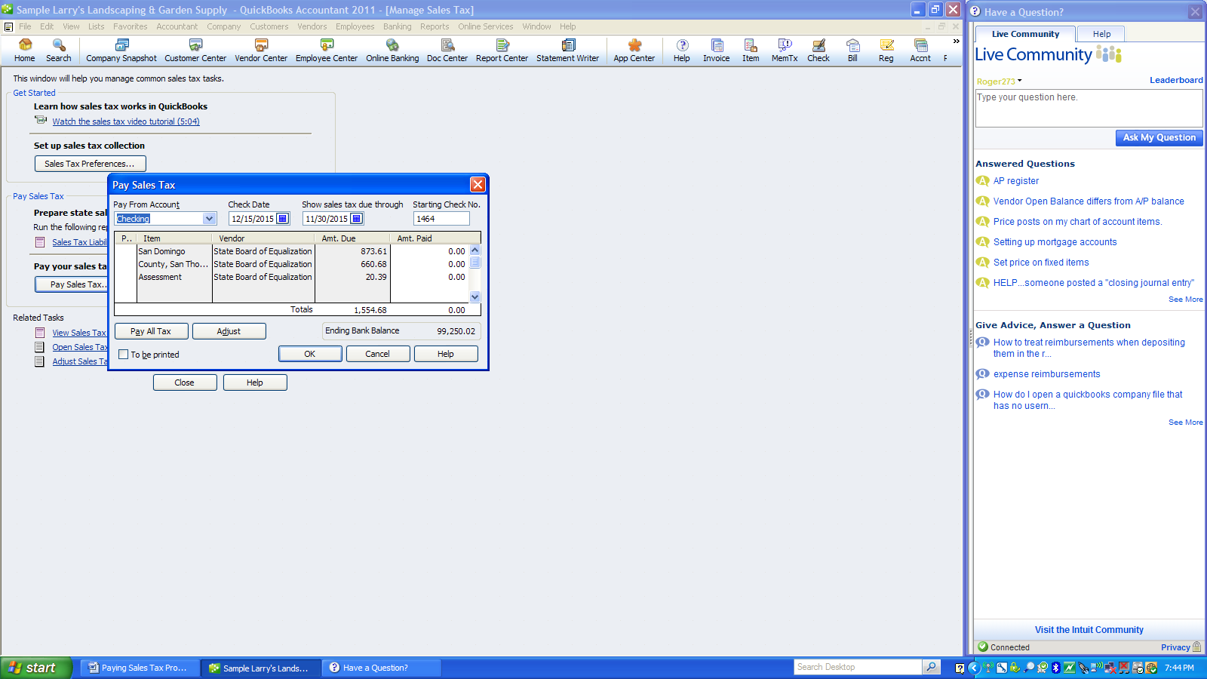
Make an adjustment for the discount if applicable
You may need to make other adjustments if there are errors in the sales processing
When everything is in balance select pay sales tax
Select the items. This should balance to the amount you are paying. Complete the different squares.
When finished select OK
